

**Manage Parkinson`s with Chair based exercise classes at CTCHealthcare**

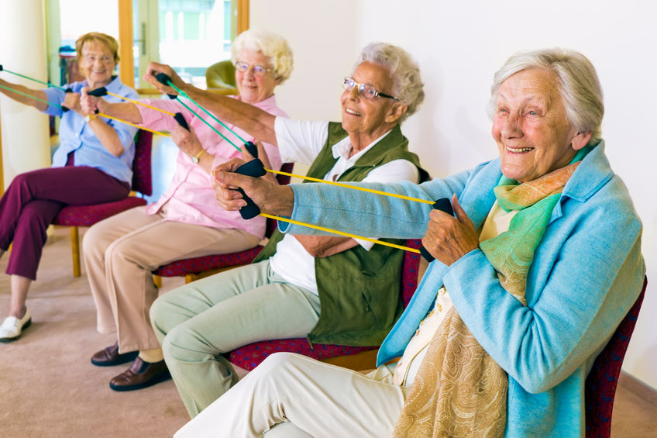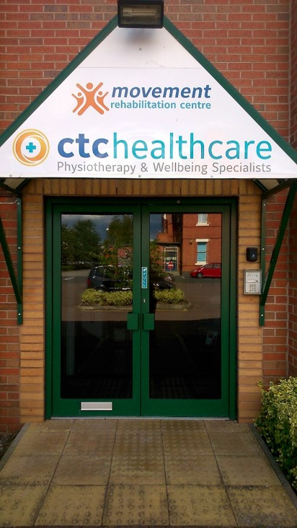

Starting on the **6th February 2019**, CTCHealthcare are offering chair based exercise classes designed for people living with Parkinson’s disease. These classes will be led by Adrianna and will be fun, motivational and designed to **help slow down and fight Parkinson’s symptoms.**

Call and speak to one of our reception team on **01270 361363** to book your place today!

**Where:** 1 George House, Beam Heath Way, Nantwich, Cheshire CW5 6PQ

**When:** Every Wednesday

**Time:** 2:30pm-3:30pm followed by provided

refreshments

**Cost:** £43 for a block of 6